***Feature extraction based thermoacoustic instability detection in premixed combustion chamber using machine learning models***

*A Project Report Submitted*

*in Partial Fulfilment of the Requirements*

*for the degree of*

**Master of Technology**

By

**Asheesh Kumar**

(18205003)

**

*To the*

Department of Mechanical Engineering

**Indian Institute of Technology Kanpur**

June 2021

**DECLERATION**

This is to certify that the thesis titled “**Feature extraction based thermoacoustic instability detection in premixed combustion chamber using machine learning models**” has been authored by me. It presents the research conducted by me under the supervision of **Prof. J. Ramkumar**.

To the best of my knowledge, it is an original work, both in terms of research content and narrative, and has not been submitted elsewhere, in part or in full, for a degree. Further, due credit has been attributed to the relevant state-of-the-art and collaborations (if any) with appropriate citations and acknowledgements, in line with established norms and practices.



Name: Asheesh Kumar

Roll No. 18205003

Programme: M. Tech

Mechanical Engineering

Indian Institute of Technology Kanpur, 208016

**CERTIFICATE**

It is certified that the work contained in the thesis titled “**Feature extraction based thermoacoustic instability detection in premixed combustion chamber using machine learning models**,” by Asheesh Kumar(Roll No. 18205003) has been carried out under my/our supervision and that this work has not been submitted elsewhere for a degree.

June 2021 **Thesis Supervisor**

**Prof. J. Ramkumar**

**Department of Mechanical Engineering**

**I.I.T. Kanpur**

# **ABSTRACT**

Name: **Asheesh Kumar**

Roll No. **18205003**

Degree for which submitted: **M. Tech**

Department: **Mechanical Engineering**

Project Title: **Feature extraction based thermoacoustic instability detection in premixed combustion chamber using machine learning models**

Project Supervisor: **Prof. J. Ramkumar**

Month and year of Project submission: **June 2021**

This study aims to predict thermoacoustic instability in premixed combustors using machine learning models, trained on thermoacoustic pressure sensor data. Thermoacoustic instability is likely to occurs in premixed combustion chamber when mixture have higher air to fuel ratio. To study the thermoacoustic instability, data was taken which contains pressure amplitude variation with respect to air flow rate. Data was divided into three classes stable, transition and unstable(instability). Time domain statical features and time-frequency domain (wavelets) features were extracted to train and test machine learning models. Different combustor configuration data were used to train and test machine learning models . Analysis of the results shows that, the Model’s performance with test data for straight section configuration was in the range of 80% - 97% and, for end plate configuration in the range of 65% - 91%. Random Forest models’ performance was 97% with time-domain features, it was better than other models’ performance in time-domain features. The performance of the SVM model with endplate configuration data was in the range of 86% to 91% for time-frequency domain features, which was better than the other three models.

**ACKNOWLEDGEMENT**

I would like to express my sincere gratitude to my thesis supervisor, Prof. J. Ramkumar for his guidance, ideas, and suggestions. His knowledge and expertise in very diverse field given me the opportunity to learn and apply a trending technology, Machine Learning and AI. His continuous support and encouragement helped me to complete my project. I am very thankful to him for his academic, research and life lessons that he has given to me. I would also like to extend my gratitude to Dr. Sathesh Mariappan (Department of Aerospace Engineering, IIT Kanpur) for his guidance and providing adequate resources required to complete my project. I would like to thank my fellow lab mates for their advice throughout the course of the project. And I am grateful to my friends and family members for their moral support and continued encouragement.

Asheesh Kumar

Roll No. 18205003

**Table of Contents**

ABSTRACT …………………………………………………………………………………… iii

ACKNOWLEDGEMENT ……………………………………………………………………. iv

LIST OF FIGURES ………………………………………………………………………….... vii

LIST OF TABLES ……………………………………………………………………………. ix

1. INTRODUCTION …………………………………………………………………………… 1

1.1 Motivation ……………………………………………...………………………...... 1

1.2 Machine Learning……………………………….…………………………….……. 1

1.3 Thermoacoustic Instability……………………………….………………………… 2

1.4 Data Acquisition …….……………….…………………………………….………. 3

1.4.1 Experimental Condition ………………………………………………… 3

1.4.2 Data Visualisation ………………………………………………………. 4

1.4.3 Data Compilation …………….…………………….…………………… 5

1.5 Flow Chart of Complete solution …………………………….…….……………… 6

1.6 Different cases of solution Approach…………………………….…...……………. 6

2. FEATURE EXTRACTION ……………………………………….…………………………. 8

2.1 Time Domain Statistical Features ……………………………………….………… 8

2.1.1 Mean………………………………………………….…….……………. 8

2.1.2 Root Mean Square (RMS)………………………………….……………. 8

2.1.3 Standard deviation ………………………………………………………. 9

2.1.4 Peak-To-Peak …………………………………………………………… 9

2.1.5 Skewness ………………………….…………………….………………. 9

2.1.6 Kurtosis ………………………………………...…………….…………. 9

2.1.7 Crest factor …………………………………………………………….. 10

2.1.8 Shape factor …………………………….………..………………….…. 10

2.2 Segmentation of data …………………………………..…………………………. 10

2.3 Time-Frequency domain features ………………………………………………… 17

2.3.1 Wavelet packet ………………………………………………………… 17

3. Machine Learning Algorithms ……………………….…………………….………………. 20

3.1 Logistic regression ………………………….……………………………………. 20

3.2 Support vector machine (SVM) ………….……….…………………………......... 22

3.3 Decision tree ………………………………….…………………………………... 23

3.4 Ensemble methods …………….…………………………………………….......... 24

3.5 Confusion Matrix …………….…………...………………………………............ 25

4. RESULTS AND DISCUSSION …………………………………………………………… 27

4.1 Model Training with time domain features ………….…………………………… 27

4.2 Model Testing with others configuration of combustion chamber ………………. 30

4.3 Model Training with time-frequency domain features (Wavelets) ………………. 35

4.4 Model Testing with time-frequency domain features ………….………………… 38

5. CONCLUSION AND FUTURE SCOPE ……………….………………….………………. 44

5.1 Conclusion …………………….……………………………….…………………. 44

5.2 Future Scope ………………….…………………………………….…….………. 45

**List of Figures**

**Figure 1.1** Experimental configuration ……………………………………………….………. 4

**Figure 1. 2** Data Visualisation …………………………………………………………...…… 4

**Figure 1.3** Compiled data from 200 SLPM to 1800 SLPM ……………….………………….. 5

**Figure 1.4** Process flow chart………………………………………………………………… 6

**Figure 1.5** Process flow chart………………………………………………………………… 7

**Figure 2.1** Segmented data ………………………………………….………….…….……… 10

**Figure 2. 2** RMS feature value variation with flow rate ………….…………………………. 11

**Figure 2.3** Mean feature value variation with flow rate ……………..………………………. 11

**Figure 2.4** Peak-To-Peak feature value variation with flow rate ……………….….………… 12

**Figure 2.5** Standard Deviation feature value variation with flow rate …………………...….. 12

**Figure 2.6** Skewness feature value variation with flow rate ………………….....…………… 13

**Figure 2.7** Kurtosis feature value variation with flow rate ……………..…………….……… 13

**Figure 2.8** Crest Factor feature value variation with flow rate …………..…………………... 14

**Figure 2.9** Shape Factor feature value variation with flow rate ………….….……………… 14

**Figure 2.10** Comparison of all time domain features ………………………………………… 15

**Figure 2.11** Feature matrix of time domain statistical features ……………………….……… 16

**Figure 2.12** Block diagram of signal decomposition …………………………….…………… 17

**Figure 2.13** Time-Frequency domain features …………………………………..…………… 18

**Figure 2.14** Feature matrix of time-frequency domain features .………………….…………. 19

**Figure 3.1** Sigmoid function ………………………………………………………….……… 20

**Figure 3.2** Graphical representation of SVM Decision boundary …………………………… 22

**Figure 3.3** Graphical representation of Decision Tree …………………………….………… 23

**Figure 3.4** Ensemble technique (Random Forest)……………………….…………………… 24

**Figure 4.1** Confusion matrices Trained on time domain features …………………………… 29

**Figure 4.2** Confusion matrices of test with 1000 mm end plate configuration …………….… 30

**Figure 4.3** Confusion matrices of test with 800mm straight section configuration .…….…… 33

**Figure 4.4** Confusion matrices of test with 800 mm end plate configuration …………...…… 34

**Figure 4.5** Confusion matrices of training with time-frequency domain features ….….……... 37

**Figure 4.6** Confusion matrices of test with time-frequency domain features ……………...…. 38

**Figure 4.7** Confusion matrices of test with time-frequency domain features ………………... 40

**Figure 4.8** Confusion matrices of test with time-frequency domain features ………………… 42

**List of Tables**

**Table 3.1** Confusion matrix ……………………………………………………...…………… 25

**Table 4.1** Training and testing accuracy ………………………………………...……………. 27

**Table 4.2** Testing accuracy and f1 score (1000 mm end plate) ……….…................................ 30

**Table 4.3** Testing accuracy (800 mm straight section) ………………….………..…………... 32

**Table 4.4** Testing accuracy (800 mm end plate) ………………………….……………..……. 33

**Table 4.5** Training and testing accuracy(time-frequency) ………………….…………...……. 35

**Table 4.6** Testing accuracies and F1 Scores (1000 mm end plate) ……………………...……. 38

**Table 4.7** Testing accuracy and F1 score (800 mm straight section) ………………………… 40

**Table 4.8** Testing accuracy and F1 score (800 mm end plate) ……………………………….. 42

**Chapter 1**

**Introduction**

**1.1 Motivation**

The Fourth Industrial Revolution combines the digital and physical worlds, ushering in a new age in disciplines such as nanotechnology, quantum computing, artificial intelligence, and the Internet of Things. Artificial intelligence being very popular due to the advancement in machine learning algorithms and development of higher computational power. Machine learning has been at the base of several recent breakthroughs in artificial intelligence. Artificial intelligence is addressing and progressing a variety of challenges, especially where humans are unable to solve the problem manually. One of the greatest instances of artificial intelligence implementation is condition monitoring and defect detection in the industrial and research sectors. The identification of current health conditions is an important part of the condition-based maintenance strategy. A related topic, condition-based maintenance in a partly premixed combustion chamber, is examined in this study [1].

**1.2 Machine learning**

In 1959, Arthur Samuel defined machine learning as a "Field of study that gives computers the ability to learn without being explicitly programmed". According to Tom Mitchell, “a computer program is said to learn from experience E with respect to some task T and some performance measure P, if its performance on T, as measured by P, improves with experience E”. The learning process plays an important role in generalizing the problem by acting on its experience. Training datasets are a source of experience for machine learning. It assists in the design of programs that enhance their performance for a specific task via experience and training. Based on the underlying mappings between input data and projected output given during the learning phase, Machine Learning algorithms may be classified into six types. It includes supervised, unsupervised, and semi-supervised learning, as well as reinforcement, transductive, and inductive learning. It is necessary to select appropriate algorithm according to the problem definition [2].

**1.3 Thermoacoustic Instability**

The uneven combustion of reacting gases causes volumetric expansion and compression of fluid near the flame zone, resulting in combustion noise. Practically combustion processes happen in confined environments. The confinement modes amplify the sound emitted by the flames at frequency near their natural frequencies, resulting in multiple peaks in the acoustic power spectrum. Consequence of these peaks in the acoustic power, the scale invariance of combustion noise in a conﬁned environment is difficult to distinguish in the acoustic power spectrum. The positive coupling of the heat release rate variation from combustion with the acoustic ﬁeld in the combustion chamber can lead to large-amplitude pressure oscillations called combustion instability or thermoacoustic instability. When trying to apply lean premixed combustion to avoid hazardous emissions, thermoacoustic instabilities are common. The engine operator can take appropriate control actions to avoid thermoacoustic instability in fielded systems by predicting the emergence of combustion instability [3-4]. Thermoacoustic instability in premixed combustion is largely dependent on type of mixture (more likely to occur in lean mixture). In this study, the data containing acoustic pressure variation with an airflow rate is used to predict thermoacoustic instability.

**1.4 Data Acquisition**

Data acquisition is a process that involves collecting information from the real world such as temperature, pressure, voltage, and sound. With the use of sensors, real-world data can be captured for computer usage. The sensitivity of the transducers utilized in this study was 215.0 mV/kPa and 219 mV/kPa. They were positioned at 450mm and 650mm from the combustor's dump plane, respectively. Using a specially manufactured stainless-steel port, both transducers were fitted on the combustor wall. [5].

**1.4.1 Experimental conditions**

The data was collected in a turbulent partly premixed combustor with a swirler for stabilization. Figure 1.1 (a) shows the experimental arrangement in cross-section. The distance between the entry and exit points of the combustion chamber is called as the length of the combustion chamber. Extension duct of different lengths (300 mm, 200 mm, 200 mm) is used to change the length of combustor. In this study, experimental data collected for 1000mm and 800mm combustor length are used for analysis. A swirler with 12 blades and a vane angle of 42°, as illustrated in Figure 1.1 (c), is installed on a 16 mm diameter shaft that is concentrically positioned with the burner. With constant area (90 mm x 90 mm) configuration, air flow rate was increased from 200 SLPM (Standard Litre Per Minute) to 1800 SLPM in steps of 100 SLPM of air and, the acoustic pressure signal recorded at sampling rate of 4096 Hz for 5 seconds.

Total sample points in each recording = Sampling rate **x** recording duration **= 4096 x 5 = 20480**

Similarly, there are 17 recorded files for 200 SLPM to 1800 SLPM which gives 20480 x 17 (=348160) sample points from one configuration of combustor [5].

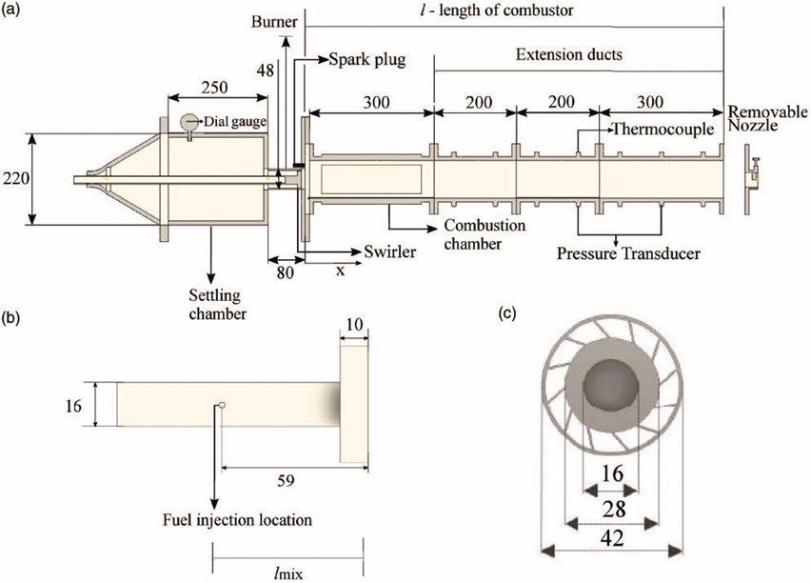

**Figure 1.1** Experimental configuration(a) cross-sectional view (b) shaft (c) swirler [5].

**1.4.2 Data visualisation**

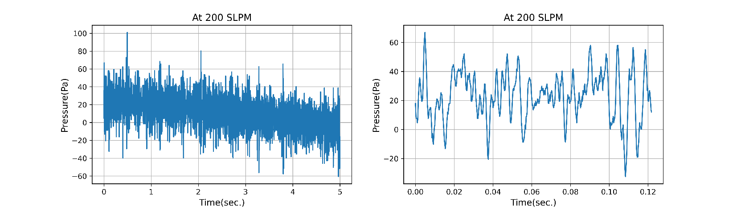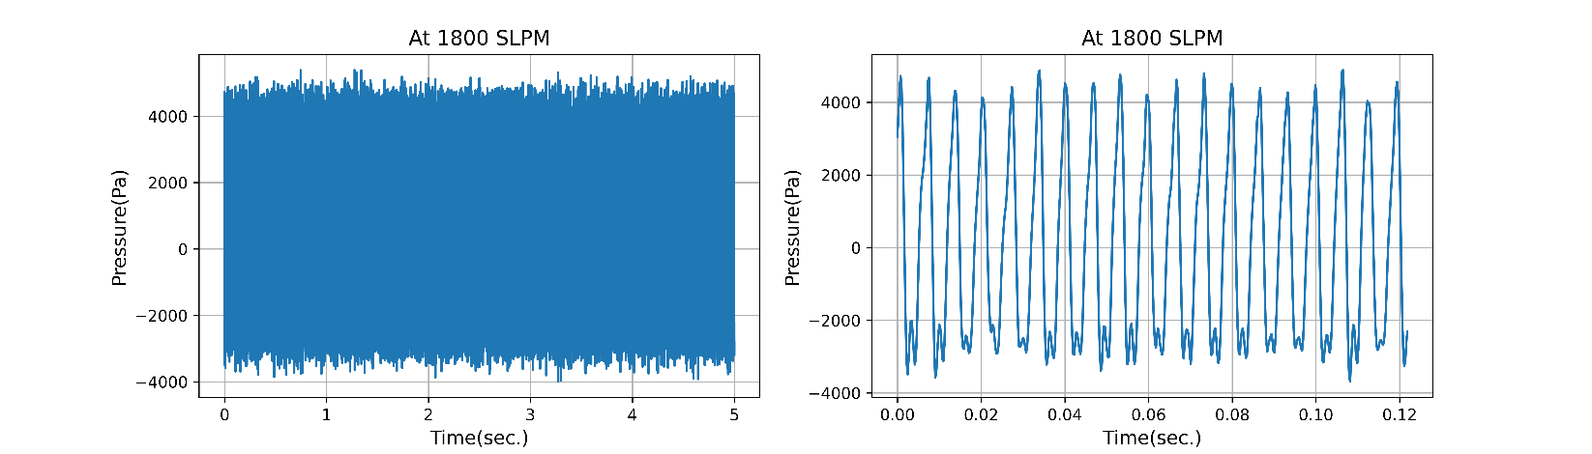

**(a)**

**(b)**

**Figure 1.2** Data Visualisation(a) at 200 SLPM(left 5 sec., right .12 sec.) (b) ) at 1800 SLPM

Figure 1.2 Shows graphical representation of signal variation. Figure 1.2 (a) represents first 5 seconds signals at 200 SLPM (left) and, first 0.12 seconds signal (right). Figure 1.2 (b) represents first 5 seconds signal at 1800 SLPM (left) and, first 0.12 seconds signal (right). Right side figure clearly represents, the chaos associated with combustion noise at the beginning (200SLPM) and pattern associated with instability at the end( 1800 SLPM).

**1.4.3 Data compilation**

The data was recorded in individual files with varying airflow rates in segments of 100 SLPM. To see the variations in the signal with respect to airflow rate, all individual files were compiled into a single file. Figure 1.3 represents the variation of acoustic pressure amplitude with air flow rate. The compiled data were further divided into three classes i.e., stable, transition, and unstable (or instability) based on some extracted features.

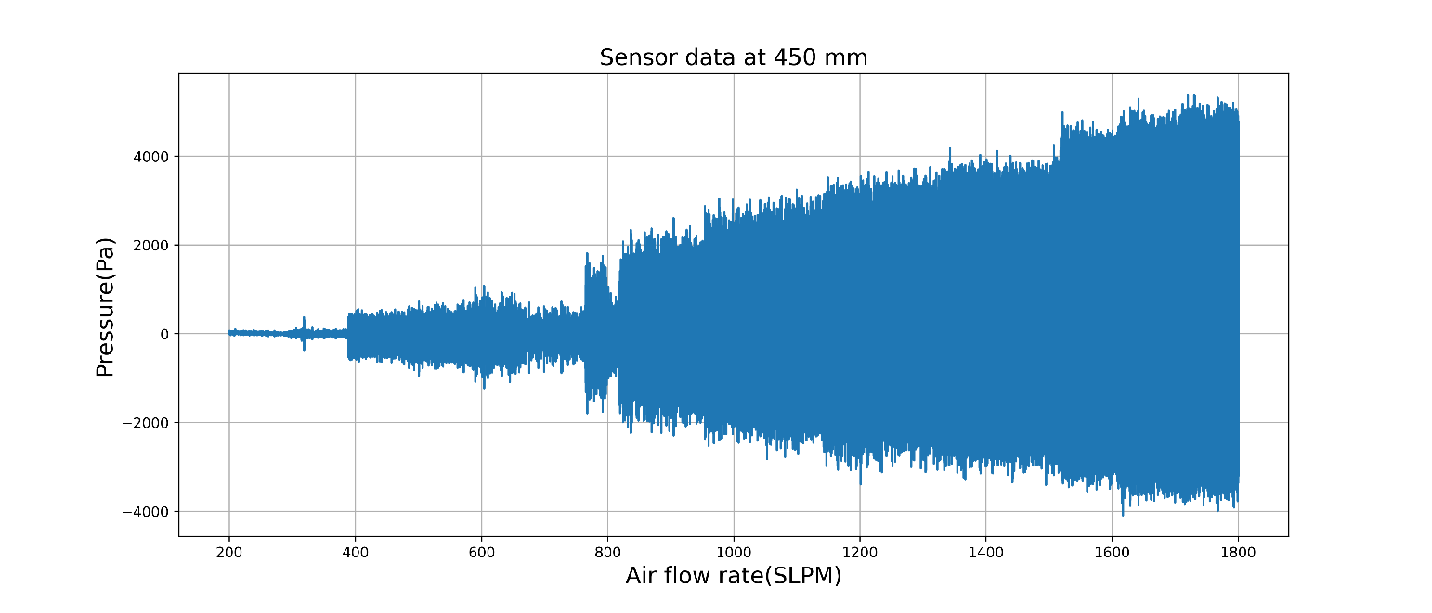

**Figure 1.3** Compiled data from 200 SLPM to 1800 SLPM

**1.5 Flow Chart of complete solution**

The steps in the problem-solving process using machine learning are depicted in Figure 1.4. First, the problem must be specified, followed by the selection of a suitable machine learning algorithm (e.g., thermoacoustic instability detection in a premixed combustor). The required data need to be collected and preprocessed in accordance with the given problem and algorithm. Based on the preprocessed data relevant feature are extracted. Further, extracted features are used for machine learning model training and testing. After the satisfactory performance of the model, it can be deployed into real-world applications.

Model Testing

Feature Extraction

Model Training

Real world application

Data Pre-processing

Problem Definition

Data acquisition

**Figure 1.4** Problem solving Process flow chart [1].

.

**1.6 Different cases for solution approach**

Figure 1.5 represents different solution approach for this study. As data were collected from two different locations (data from the transducer at 450 mm and data from the transducer at 650 mm). for analysis either data from the first transducer can be used, or data from the second transducer can be used. As both the data were recorded under similar operating conditions hence, they are highly correlated. Because of high correlation, both cannot be used simultaneously. Time domain and time-frequency domain data were used to extract the features. Various machine learning models were trained using extracted features.

Time Domain

Time Frequency Domain

Time Frequency Domain

Time Domain

Transducer at 450 mm

Transducer at 650 mm

Data

Logistic regression

Support Vector Machine

Decision Tree

Random Forest

Logistic regression

Support Vector Machine

Decision Tree

Random Forest

**Figure 1.5** Flow chart of different cases of solution approach.

**Chapter 2**

**Feature Extraction**

Because a machine learning model cannot interpret the raw signal, features are important parameters for them. Raw signals are represented by features, which facilitate in the learning of the signals by the model. When appropriate features from the raw signal are extracted, most machine learning models produce accurate results.

**2.1 Time domain statistical features**

From the signal across historical time, time domain features are computed using statistical method. To compute features, a signal reflecting the amplitude fluctuation of voltage or thermoacoustic pressure with time interval was utilized.

**2.1.1 Mean**

Mean value of the data, is calculated using average of data from sampled interval. mean =

where xirepresentsthe magnitude of sample data, ‘n’ represents the total number of data points in sampled interval [5].

**2.1.2 Root Mean Square (RMS)**

The variance of magnitude of the signal, is represented by RMS value of signal. Mathematically RMS value is calculated using following formula [6].

RMS =

**2.1.3 Standard deviation**

Standard deviation is one of the important statistical features to identify fluctuation in the signal, basically, it represents the deviation from the mean value of data [6].

SD =

where x̄ is the data's mean value across the sampled interval.

**2.1.4 Peak-To-Peak**

The difference between the greatest value and smallest value in the sampled interval is known as peak to peak [6].

peak-to-peak = max(xi) – min(x­i)

**2.1.5 Skewness**

Skewness is defined as the ratio of the third moment to the standard deviation's cube. It compares the probability distribution of the signal to the probability distribution of the normal distribution, to inspect asymmetry in the signal (normal distribution is a bell-shaped curve, which is symmetrical about its mean) [6].

skewness =

**2.1.6 Kurtosis**

Like skewness, kurtosis is the ratio of fourth moment to fourth order of standard deviation. Kurtosis is a relative statistical measurement; it measures the peakiness in the signal with respect to the normal distribution. The mathematical formula to calculate kurtosis is given below, where parameters representing the same meaning as discussed previously [6].

kurtosis =

**2.1.7 Crest factor**

Crest factor is computed from the greatest value in the sampled interval divided by the RMS value of sampled interval [6].

Crest =

**2.1.8 Shape factor**

Shape factor is computed from the RMS value in the sampled interval divided by the mean value of sampled interval. the mathematical expression is given below with the same meanings of the parameters as discussed previously [6].

shape factor =

**2.2 Segmentation of data**

All the above statistical features are extracted from the sampled interval. Dividing a dataset into several intervals called segmentation of data. Segmentation of data helps in the identification of the status of combustion with respect to time. Without segmentation, a dataset is represented by only one feature value, however after segmentation, a dataset is represented by several feature values. Figure 2.1 represents the number of intervals, created in a dataset.

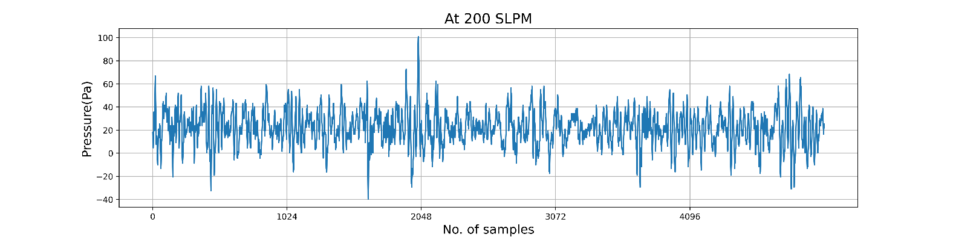

**Figure 2.1** Graphical representation of segmentation of data

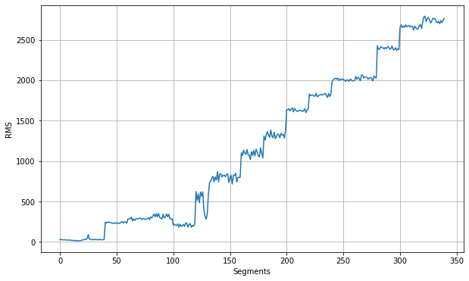

**Figure 2.2** RMS feature value variation with flow rate

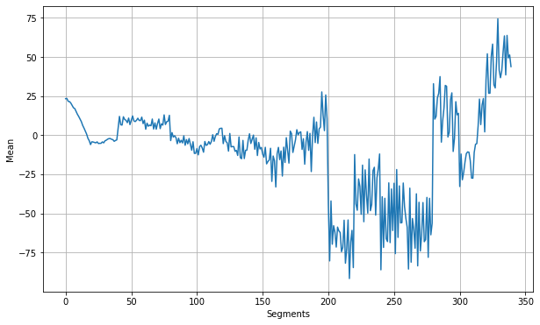

**Figure 2.3** Meanfeature value variation with flow rate

Figure 2.2 and Figure 2.3 Represents variation of RMS value and mean value, respectively, on ordinate and Segmented data points on abscissa.

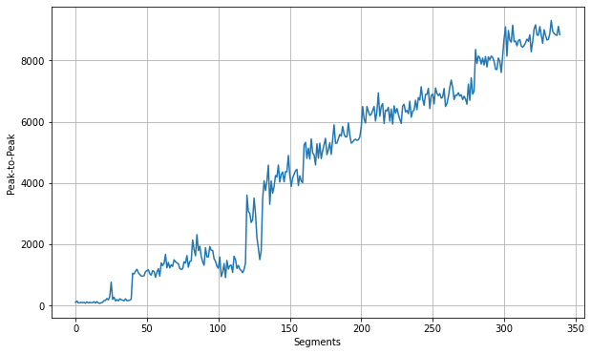

**Figure 2.4** Peak-To-Peak Plot feature value variation with flow rate

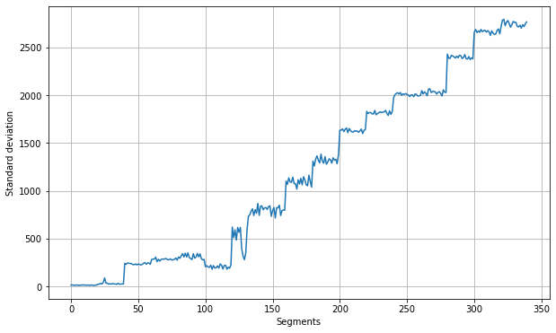

**Figure 2.5** Standard Deviation feature value variation with flow rate

Figure 2.4 and Figure 2.5 Represent the variation of the Peak-to-Peak and Standard Deviation values, respectively, on the ordinate and Segmented data points on the abscissa.

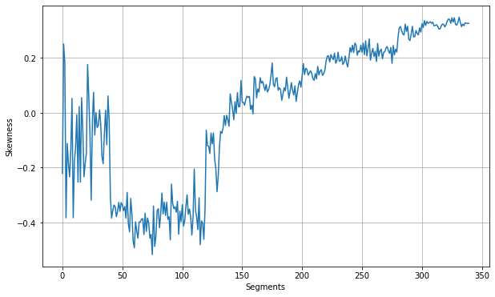

**Figure 2.6** Skewness feature value variation with flow rate

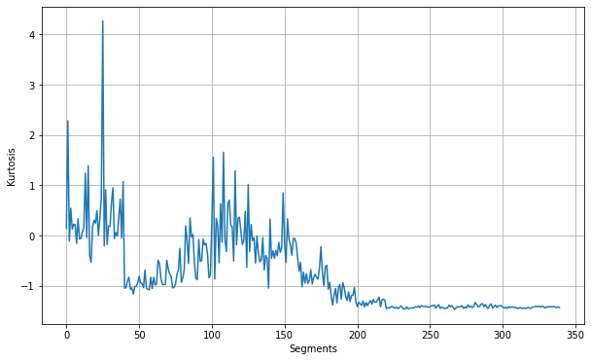

**Figure 2.7** Kurtosis feature value variation with flow rate

Figure 2.6 and Figure 2.7 Represents variations of the Skewness value and Kurtosis value, respectively, on the ordinate and segmented data points on the abscissa.

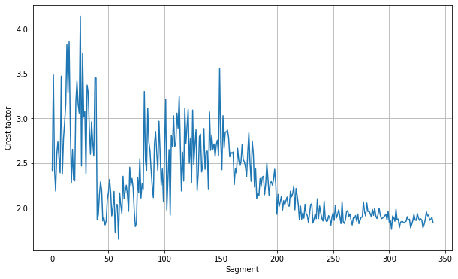

**Figure 2.8** Crest Factor feature value variation with flow rate

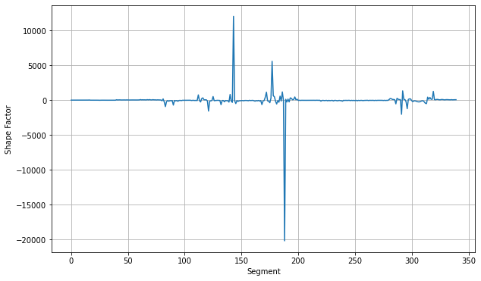

**Figure 2.9** Shape Factor feature value variation with flow rate

Figure 2.8 and Figure 2.9 Represent variations of the Crest Factor value and Shape Factor value, respectively, on the ordinate and Segmented data points on the abscissa.

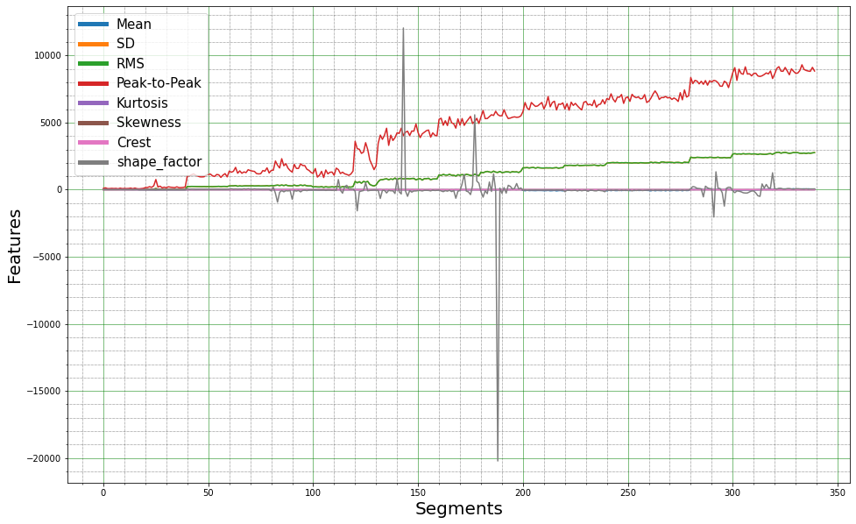

**Figure 2.10** Comparison of time domain features.

Figure 2.10 Represents Variation of all the time domain features magnitude on ordinate and airflow rate (or a number of segments) on the abscissa. All features are compared in figure 2.10 to check the status in the combustion. Using these features machine learning models can identify or differentiate the status in the combustion chamber. The variation in the signals is captured by the features which intern helps machine learning models to understand the signals effectively. Because the magnitude of some features (e.g., peak-to-peak, RMS, etc.) is greater than that of others, smaller magnitude features are hidden behind larger magnitude features. Manually identifying the status of combustion from time-domain features is extremely difficult; however, machine learning methods automatically determine the status of combustion.

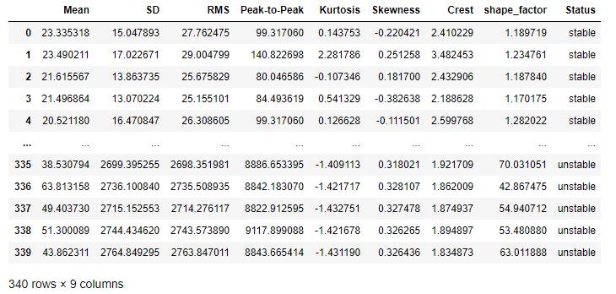

**Figure 2.11** Feature matrix of time domain statistical features.

Figure 2.11 shows the time-domain feature matrix obtained from 1000 mm straight section configuration data. There are 340 rows and 9 columns. First, eight-column represents time-domain features, and each row represents a segment from which features were calculated. The last column represents the status of the combustion. These 340 rows are the training examples for the machine learning models. The first eight columns (feature values) are used as input to the machine learning models and the corresponding values in the last column as output from the model.

**2.3 Time-Frequency domain features**

Time-domain features contain information of signal variation with respect to time, but time-frequency domain features contain information of signal variation both in time and frequency [6].

**2.3.1 Wavelet packet**

Wavelet packets is a small wave which scans the complete signal and decomposes into detailed and approximation signals. This detailed and approximation signals further decompose into detailed, and approximation signals. This process continues till the defined level as shown in Figure 2.12 below. The outcome of wavelet packets is some coefficients that are used as the time-frequency domain features. In this study decomposition up to level three is used. There are many wavelet families (e.g., Haar, Doubechies, Symlets, Morelet, etc). The type of problem specification determines which wavelet families should be used. The sym8 wavelet from the symlets wavelets family was utilized in this study. Symlets are nearly symmetrical geometrically. Signal decomposition up to level three yielded eight coefficients. The obtained coefficients, which range from 0 to 7, were used as features [7].

Signal

Approximation(A)

Detailed(D)

A

D

A

D

A

D

A

D

A

D

A

D

Level 1

Level 2

Level 3

**Figure 2.12** Signal decomposition block diagram.

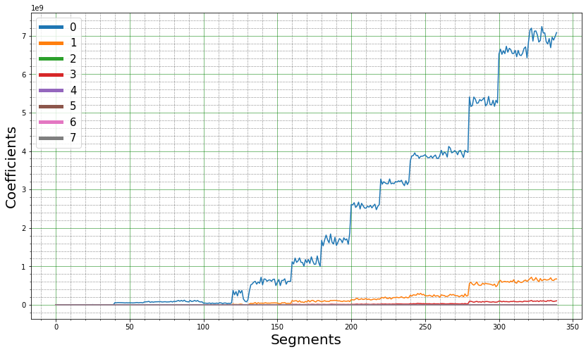

**(a)**

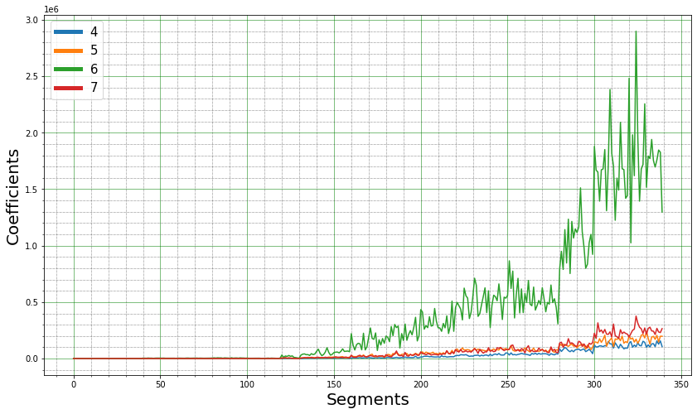

**(b)**

**Figure 2.13** Time-Frequency domain features. (a) all features. (b) last four features.

Figure 2.13 Shows time-frequency domain features extracted from 1000 mm straight section configuration data. (a) represents all eight(0 - 7) features. (b) represents last four features (4 - 7).

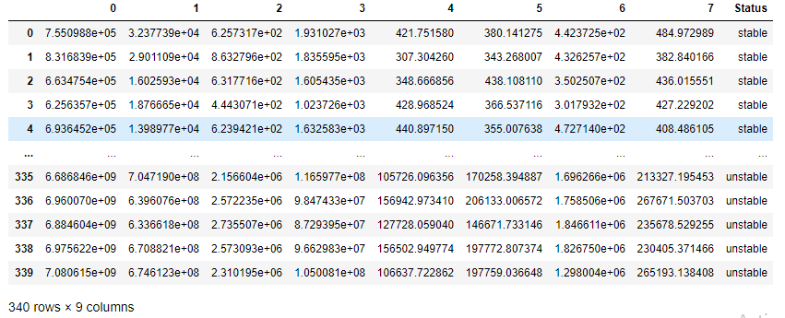

**Figure 2.14** Feature matrix of time-frequency domain features.

Figure 2.11 Represents the feature matrix of time-frequency domain features, calculated from 1000 mm straight section configuration data. There are 340 rows and 9 columns. First, eight-column represents time-frequency domain features, and each row represents a segment from which features were calculated. The last column represents the status of the combustion. These 340 rows are the training examples for the machine learning models. The first eight columns (feature values) are used as input to the machine learning models and the corresponding values in the last column as output from the model.

**Chapter 3**

**Machine Learning Algorithms**

Supervised Machine learning algorithms were used, according to the problem definition for this study. Supervised learning deals with labelled data. It can be further divided into regression and classification types of problems. In regression problems, outputs are continuous values, and in classification, outputs are discrete values (type of classes) [8]. Following are some supervised classification algorithms used in this study.

**3.1 Logistic regression**

Among the most fundamental machine learning techniques for classification is logistic regression. In this algorithm sigmoid or logistic function used as the hypothesis of the algorithm. The input to the logistic function is the summation of the product of weight and corresponding feature value (z). It is categorised as class 1 when z is positive, and as class 0 when z is negative. Logistic regression is a binary classification algorithm [8].

z =

h(z) =

]

Where wi is the coefficients corresponding to features xi. y is actual output(class) and is output predicted by hypothesis h(z) and ‘m’ is the total number of training examples available. Error in prediction is called as Cost (). The main objective is to minimise the cost () function by optimising the coefficients. To minimise this cost function, gradient descent or stochastic gradient descent method are used. The weight update equation in gradient descent is given as following.

= – α

Where is new weight and is former weight. is gradient of cost function and α is called as learning rate (to regulate the convergence speed). From the equation, tends to as gradient reaches to zero. When the cost function is at its minimum, its gradient is zero. But this method works only when the cost function is convex(convex function has only one minimum), for non-convex functions there is an advanced method to solve the optimization problem. For more generalization of the model, regularisation can be used. Regularisation penalizes the model for overfitting the training data. The amount of regularisation depends on the parameter called regularisation parameter [7].

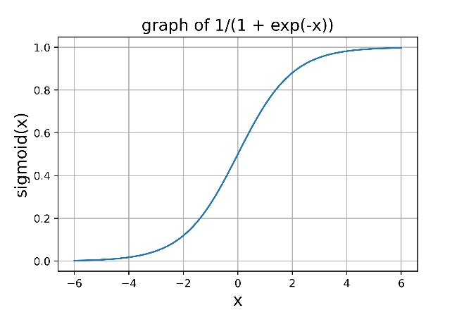

**Figure 3.1** Graph of Sigmoid function

**3.2 Support vector machine (SVM)**

Support vector machines are a supervised learning algorithm like Logistic regression, it also uses sigmoid function to make hypothesis. As shown in Figure 3.2 (a) there is an infinite number of decision boundaries possible. As shown in figure 3.2 (b) in the SVM algorithm, the decision boundary with the greatest margin is chosen. The margin is the distance between support vectors, which are the lines that pass through the data points closest to the decision boundary. Because of the higher margin in the SVM algorithm, it can make more accurate predictions than Logistic Regression. Margin in SVM classifier comes out as following.

Margin =

||w|| is the magnitude of weights, like Logistic Regression. The primary objective is to maximize the margin and obtain optimum weights. In the SVM algorithm, when data are not linearly separable then kernel functions are used to make nonlinear boundaries. Different kernel functions are used in place of feature values, depending on the type of problem and non-linearity in the decision boundary. For multi-class classification problems, multiple decision boundaries are created to learn the data. [8].

Support vectors

Hyperplane

**(a) (b)**

**Figure 3.2** Graphical representation of SVM Decision boundary [6]

**3.3 Decision tree**

The decision tree is a set of nodes arranged in the shape of a tree, with the root node at the top and all leaf nodes at the bottom. The root node is divided into two sub-nodes, further, these nodes are also divided into two sub-nodes, this process continues till the leaf nodes are reached. Each leaf node represents a class output of decision tree. A parameter value termed entropy is determined for each node with regard to all features, the feature with the highest entropy allocated to that node with a threshold value. Gini Impurity, a metric similar to entropy, may also be used to assign features at a node since it is more computationally efficient than entropy. [9].

**Figure 3.3** Graphical representation of Decision Tree [8].

Mathematical formula to calculate decision parameters are as following.

Entropy H(y) =

Gini Impurity (IG­) = 1 -

represents the probability of random variable y taking i­­­th value.

**3.4 Ensemble methods**

Ensemble methods are used to enhance the model performance. Multiple individual models are merged in ensemble techniques. The results of each model are merged to provide a single overall model output. Each model is trained using randomly sampled dataset, which are called base learners. There are mainly four types of ensemble methods, Bagging, Boosting, Staking, and Cascading. Random forest is a type of bagging technique and used for high classification accuracy. In Random Forest, the Decision Tree is used as the base learner [9-10].

`

M1

M2

M3

M

**Figure 3.4** Ensemble technique (Random Forest) block diagram

In Figure 3.4, Dn is the complete dataset, and Dn1, Dn2­, and Dn3 are the randomly sampled data from the complete dataset Dn. Sampled dataset Dn1, Dn2­ , and Dn3 are used to train the base learner models M1, M2, and M3, respectively. As each model is trained using different datasets, hence they produce different outputs. Then the output from these models is sent to model M, which aggregates all the outputs from individual models and gives the final output.

**3.5 Confusion Matrix**

A confusion matrix is a table of the predicted class by model and true class, the number of items in a row represents true class and the number of items in a column represents predictions by the model, as shown in Figure 3.5. A confusion matrix is used to evaluate how well a classification model performs. The confusion matrix gives the number of correct predictions and incorrect predictions by models out of true values. But it does not give any single value to assess the overall model performance [10].

**Figure 3.5** Confusion matrix

TP: True Positive

FP: False Positive

FN: False Negative

Accuracy = = Total number of accurate classifications from all data points.

Precision = = Ratio of the number of right classifications to the predictions in a class.

Recall = = Ratio of the number of right classifications to the true data points in a class.

F1 Score =

The number of correct predictions divided by the total number of data points is known as accuracy. Accuracy measures an overall model performance, it does not include the individual class performance. F1 score calculates recall from each class, calculates predicted accuracy, and combines them to give an overall model performance. Hence, the F1 score measures individual class performance. For class balance problems accuracy and F1 scores give a similar model performance. For the class imbalance problem, F1 score gives a better measurement of model performance [7].

**Chapter 4**

**Results And Discussion**

In this chapter, four machine learning models are trained and compared their performance with test data. Extracted features from training data have a different range of magnitude. To tackle this problem, feature standardization is used before training any model.

**4.1 Model Training with time domain features**

The data was split into two categories: training and testing, with training accounting for 75% of the total and testing accounting for 25%. (Because the total amount of data available is limited, testing data has been used less to increase training data). Training data was used to updates the weights by minimizing the cost function, and testing data was used to validate the model's learning. Accuracy and F1 score were used as performance measuring parameters for each model. Accuracy and F1 scores measure overall model performance, while the confusion matrix gives more insights into classified data for an individual class. From the extracted features in chapter two, there were 340 data points in the dataset. 255 (75%) data points were taken for training, and 85 (25%) data points were taken for testing, based on random selection. The accuracies and F1 scores obtained from individual trained models are listed below in table 4.1.

|  |  |  |
| --- | --- | --- |
| Algorithms | Training Accuracy | Testing Accuracy |
| Logistic regression | 0.996 | 1.0 |
| Decision Tree | 1.0 | 1.0 |
| SVM | 1.0 | 1.0 |
| Random Forest | 1.0 | 1.0 |

**Table 4.1** Training and testing accuracy in time domain features

The accuracies of each model are quite high, as seen in Table 4.1. The excellent training accuracy is due to the fact that, it is computed using the same data that was used for training the model. Training accuracy gives an understanding of how well the model has learned the training data. High training accuracy of models indicates that, all model has learned the training data extremely well. As testing accuracy is calculated using data that was not seen by the model in training, and testing accuracies are high, it means model also performs well with new data.

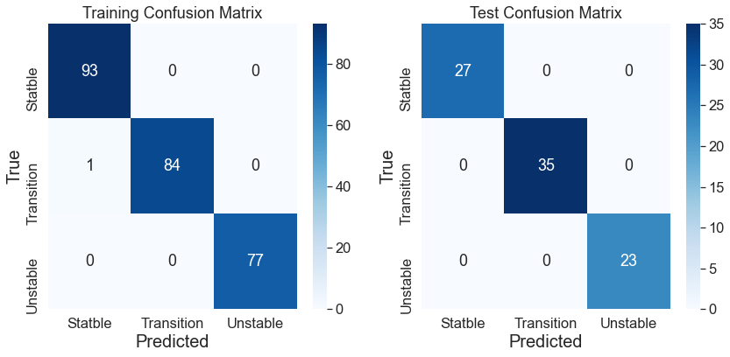

**(a)**

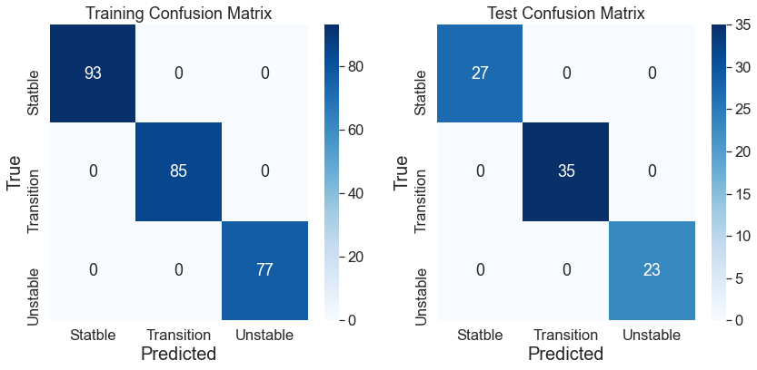

**(b)**



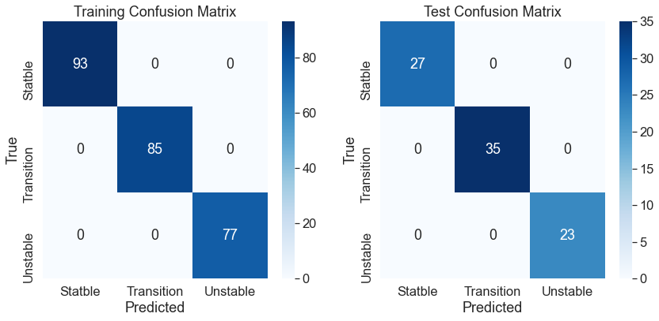**(c)**

**(d)**

**Figure 4.1** Confusion matrices Trained on time domain features.

Figure 4.1 Represents confusion matrices obtained from the training of models (left side) and testing of same models (right side). Figure 4.1 (a) represents the confusion matrix of the Logistic Regression model, (b) the Decision Tree model, (c) the SVM model, (d) the Random Forest model. There was only one incorrect classification (transition is predicted as a stable condition) in the training of the Logistic Regression model. which means the model has captured almost all data while learning. In the test confusion matrix, there was no incorrect classification by any model, because of the same combustor configuration data used for testing the models.

**4.2 Model Testing with different configurations of combustion chamber**

|  |  |  |
| --- | --- | --- |
| Algorithms | Testing Accuracy | F1 Score |
| Logistic regression | 0.65 | 0.63 |
| Decision Tree | 0.63 | 0.58 |
| SVM | 0.64 | 0.61 |
| Random Forest | 0.66 | 0.63 |

**Table 4.2** Testing accuracy and F1 score (1000 mm end plate)

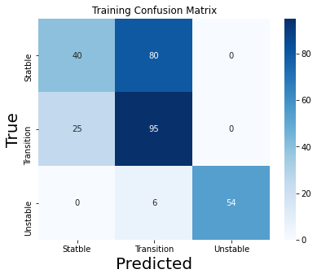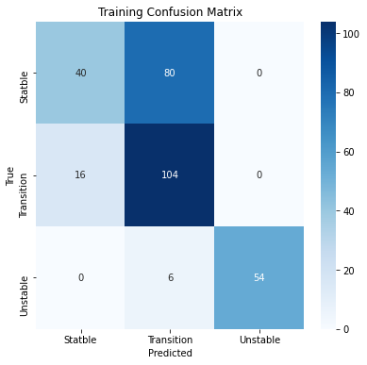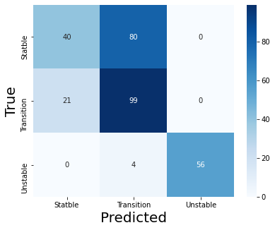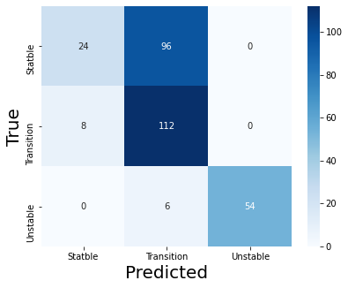

**(a) (b)**

**(c) (d)**

**Figure 4.2** Confusion matrices of test with 1000 mm end plate configuration.

Second configuration (i.e.,1000 mm length with end plate configuration) data was used to test previously trained models. Table 4.2 represents the testing accuracy and F1 score of all models. Along with accuracy, F1 scores were also calculated to handle class imbalance, which was observed in this data. The accuracies for Logistic Regression, Decision Tree, SVM, and Random Forest models were 0.65, 0.63, 0.64, and 0.66, respectively, while the F1 were 0.63, 0.58, 0.61, and 0.63, respectively, as shown in Table 4.2. The accuracies were less in each model due to end plate configuration data, which contains a high amplitude of acoustic pressure as compared to straight section configuration(which was used to train the models).

Figure 4.2 shows the confusion matrices of models, tested with 1000 mm end plate configuration. (a) Indicates Logistic Regression, (b) Indicates Decision Tree, (c) Indicates SVM, and (d) Indicates Random Forest. Considering figure 4.2(a), the true classes are represented in the horizontal direction and predicted classes (by model) represented in the vertical direction. There was total 120 true(or actual) points in the stable class out of which 40 were predicted as stable(33% recall) and 80 were predicted as transition class. For transition class, there were total 120 true data points, out of which 21 were predicted as stable and 99 were predicted as transition class(82.5 % recall). There was a total 60 true classes in unstable (or instability status) out of which 4 were classified as transition class and the rest 56 were classified as unstable class(93 % recall). It means his model had better recall for unstable class than transition and stable classes. Figure 4.2 (b), Decision Tree's recall were 20% in stable class, 93% in transition class, and 90% in unstable class. In Figure 4.2 (c) SVM recall were 33% in stable class, 79% in transition class, and 90% in unstable class. In Figure 4.2 (d) Random Forest recalls were 33% in the stable class, 86% in the transition class, and 90% in the unstable class.

**Table 4.3** Testing accuracy (800 mm straight section)

|  |  |  |
| --- | --- | --- |
| Algorithms | Testing Accuracy | F1 score |
| Logistic regression | 0.80 | 0.80 |
| Decision Tree | 0.86 | 0.86 |
| SVM | 0.85 | 0.85 |
| Random Forest | 0.97 | 0.97 |

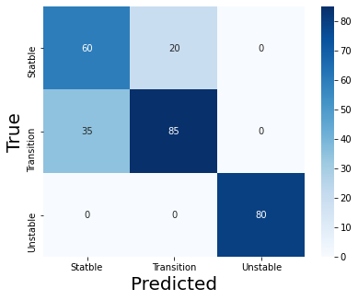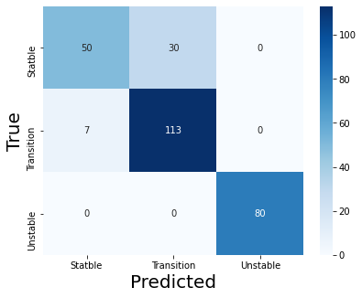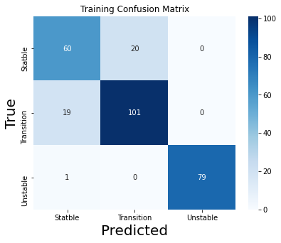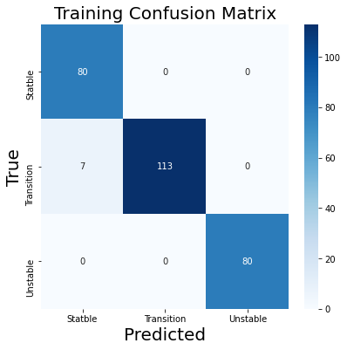

**(a) (b)**

**(c) (d)**

**Figure 4.3** Confusion matrices of test with 800mm straight section configuration

Table 4.3 represents the accuracy and F1 scores of the models, tested with 800 mm length straight section combustor configuration data. The accuracies for Logistic Regression, Decision Tree, SVM, and Random Forest models were 0.80, 0.86, 0.85, and 0.97, respectively, while the F1 were 0.80, 0.86, 0.85, and 0.97, respectively, as shown in Table 4.3. The accuracy of the Random Forest model was better than other models' accuracies, with this combustor configuration test data.

Figure 4.3 shows the confusion matrices of models tested with 800 mm straight section configuration. (a) Indicates Logistic Regression, (b) Indicates Decision Tree, (c) Indicates SVM, and (d) Indicates Random Forest. There were 80,120 and 80 true values of stable class, transition class, and unstable class, respectively. Out of these true values, Logistic regression recall was 75% in stable class, 70% in transition class, and 100% recall for unstable class. Decision Tree recall was 62.5% in stable class, 94% in transition class, and 100% recall in unstable class. SVM recall was 75% in stable class, 84% in transition class, and 98.75% recall in unstable class. Random Forest recalls was100% in stable class, 94% in transition class, and 100% in unstable class. Random Forest was an ensemble method, uses a Decision Tree as a base learner. Base learners were trained on randomly sampled data, the aggregate output of base learners makes Random Forest performance better than the Decision Tree performance.

|  |  |  |
| --- | --- | --- |
| Algorithms | Testing Accuracy | F1 Score |
| Logistic regression | 0.69 | 0.65 |
| Decision Tree | 0.70 | 0.64 |
| SVM | 0.60 | 0.56 |
| Random Forest | 0.80 | 0.79 |

**Table 4.4** Testing accuracy (800 mm end plate)

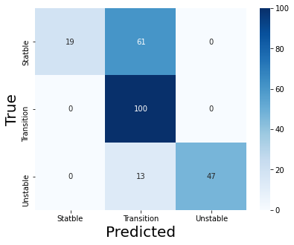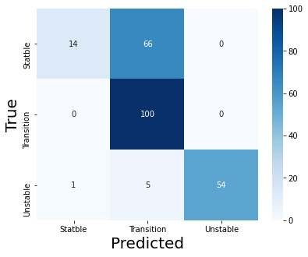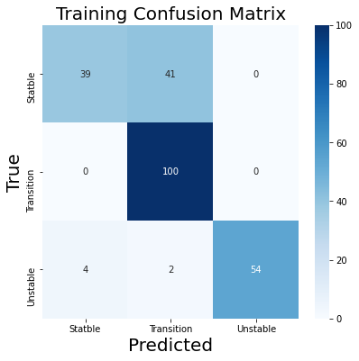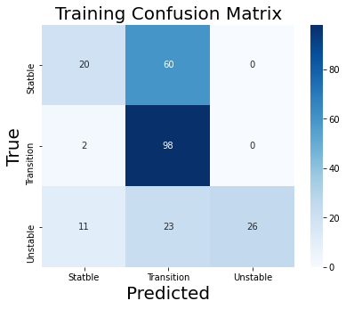

**(a) (b)**

**(c)** **(d)**

**Figure 4.4** Confusion matrices of test with 800 mm end plate configuration

Table 4.4 represents the accuracy and F1 scores of the models, tested with the 800 mm length end plate combustor configuration data. The accuracies for Logistic Regression, Decision Tree, SVM, and Random Forest models were 0.69, 0.70, 0.60, and 0.80, respectively, while the F1 were 0.65, 0.64, 0.56, and 0.79, respectively, as shown in Table 4.4. There was a significant difference between accuracies and F1 score, which means the model performance was unequal in each class. The accuracy of the Random Forest model was better than other models' accuracy. The difference between accuracy(80%) and F1 score(79%) was also very less as compared to other models, which means Random Forest performance was better than other models' performance, for individual class classification.

Figure 4.4 shows the confusion matrices of the model tested with an 800 mm length end plate configuration. (a) Indicates Logistic Regression, (b) Indicates Decision Tree, (c) Indicates SVM, and (d) Indicates Random Forest. There were 80,100 and 60 true values for stable class, transition class, and unstable, respectively. Out of these true values, Logistic Regression recall was 76% in stable class, 100% in transition class, and 78% in unstable class. Decision Tree recall was 82.5% in stable class, 100% in transition class, and 90%, in unstable class. SVM recall was 25% in stable class, 98% in transition class, and 43.33% in unstable class. Random Forest recall was 51% in stable class, 100% in transition class, and 90% in unstable class.

**4.3 Model Training with time-frequency domain features (Wavelets)**

|  |  |  |
| --- | --- | --- |
| Algorithms | Training Accuracy | Testing Accuracy |
| Logistic regression | 0.98 | 0.97 |
| Decision Tree | 0.99 | 0.97 |
| SVM | 0.98 | 0.98 |
| Random Forest | 1.0 | 1.0 |

**Table 4.5** Training and testing accuracy(time-frequency)

Table 4.5 represents the training and testing accuracies of models trained using time-frequency domain features (wavelets). Training accuracies of Logistic Regression, Decision Tree, SVM, and Random Forest models were 98%, 99%, 98%, and 100% respectively. Testing accuracies of Logistic Regression, Decision Tree, SVM, and Random Forest are 97%, 97%, 98%, and 100% respectively. Training and testing accuracy was quite well in all models, which means all models learned the training data very well.

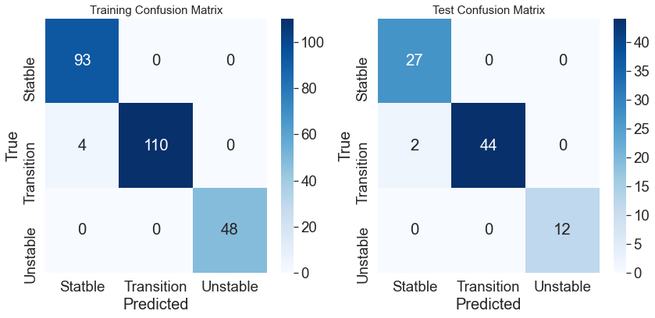

**(a)**

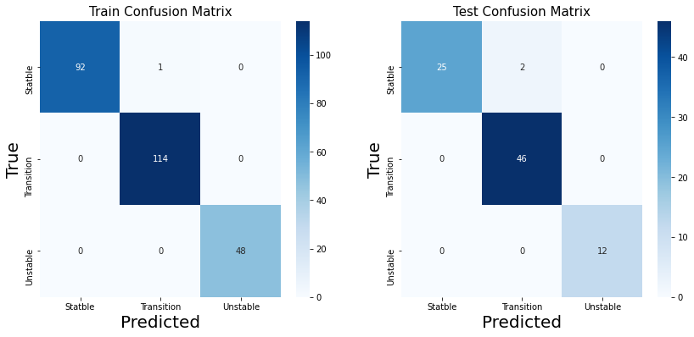

**(b)**

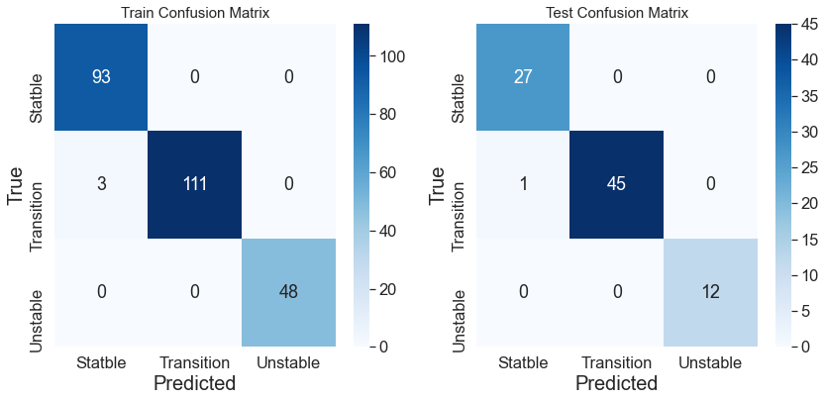

**(c)**

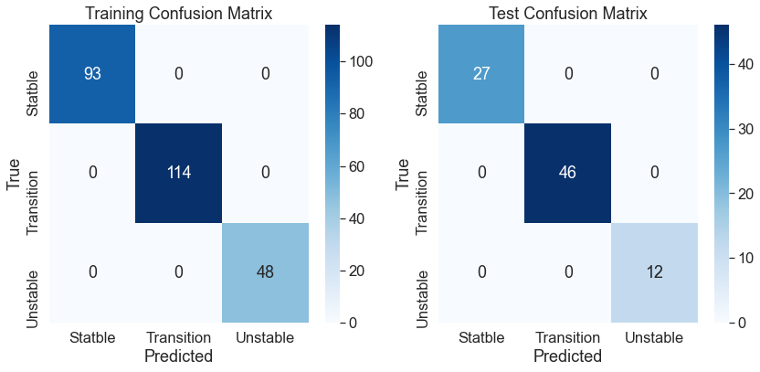

**(d)**

**Figure 4.5** Confusion matrices of training with time-frequency domain features

Figure 4.5 Represents confusion matrices obtained from the training of models (left side) and testing of same models (right side). Figure 4.1 (a) represents the confusion matrix of the Logistic Regression model, (b) represents the confusion matrix of the Decision Tree model, (c) represents the confusion matrix of the SVM model, (d) represents the confusion matrix of Random Forest model. In the training of models, the Logistic Regression model could not learn 4 data points in a stable class, the Decision Tree model could not learn 1 data point in transition class and the SVM model could not learn 3 points in a stable class. In testing of the models, Logistic Regression could not recall 2 data points in transition class, Decision Tree could not recall 2 data points in stable class and SVM could not recall 1 point in transition class. Random Forest has recalled all the classes perfectly. The performance of all the models was over 98% with the same configuration data. Training and testing accuracies of the models with time-frequency features were slightly less than training and testing accuracies with time-domain features data.

**4.4 Model Testing with time-frequency domain features**

|  |  |  |
| --- | --- | --- |
| Algorithms | Testing Accuracy | F1 Score |
| Logistic regression | 0.79 | 0.72 |
| Decision Tree | 0.80 | 0.74 |
| SVM | 0.86 | 0.80 |
| Random Forest | 0.80 | 0.74 |

**Table 4.6** Testing accuracies and F1 Scores (1000 mm end plate)

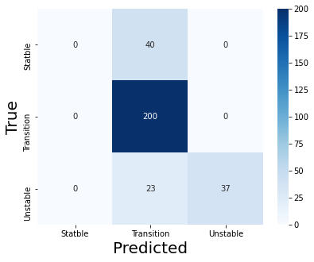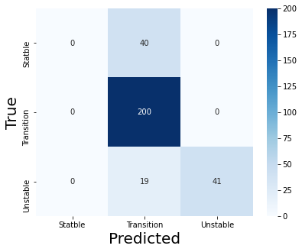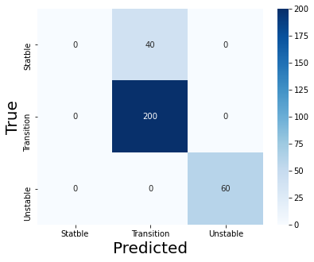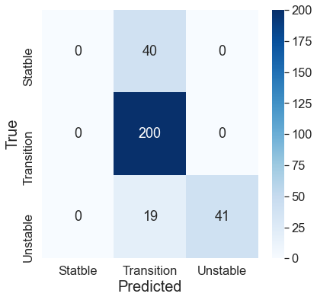

**(a) (b)**

**(c) (d)**

**Figure 4.6** Confusion matrices of test with time-frequency domain features(1000 mm end plate)

Second configuration (i.e., 1000 mm length with end plate configuration) data was used to test these already trained models. Table 4.6 represents the testing accuracy and F1 scores of all models tested with this data. The accuracies for Logistic Regression, Decision Tree, SVM, and Random Forest models were 0.79, 0.80, 0.86, and 0.80, respectively, while the F1 were 0.72, 0.74, 0.80, and 0.74, respectively, as shown in Table 4.6. There was a significant difference (4% to 7%) between accuracy and F1 score in each model. Significant difference between accuracies and the F1 score represents the unequal performance in each class.

Figure 4.6 shows the confusion matrices of models tested with 1000 mm end plate configuration. (a) Indicates Logistic Regression, (b) Indicates Decision Tree, (c) Indicates SVM, and (d) Indicates Random Forest. There was total 40 true(or actual) points in stable class out of which 0 was predicted as stable(0% recall) and 40 was predicted as transition class. In transition class, there were total 200 true data points out of which 200 predicted as transition class(100% recall). And there were total 60 true data points in unstable class out of which 23 were classified as transition class and the rest 37 is classified as unstable class(61 % recall). So, this model had a better recall for transition class than stable and unstable classes. Figure 4.2 (b), Decision Tree recall was 0% in stable class, 100% in transition class, and 68% in unstable class. In Figure 4.6 (c) SVM recall was 0% in stable class, 100% in transition class, and 100% in unstable class. In Figure 4.2 (d) Random Forest recall was 0% in stable class, 100% in transition class, and 68% in unstable class. As no modes could recall any data point from stable class, although accuracies were more than accuracies in the time-domain feature models. Hence, a model trained on straight section configuration does not perform well with end plate configuration in the time-frequency domain feature.

**Table 4.7** Testing accuracy and F1 score (800 mm straight section)

|  |  |  |
| --- | --- | --- |
| Algorithms | Testing Accuracy | F1 Score |
| Logistic regression | 0.82 | 0.80 |
| Decision Tree | 0.68 | 0.58 |
| SVM | 0.72 | 0.69 |
| Random Forest | 0.62 | 0.53 |

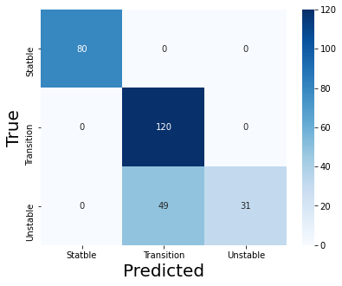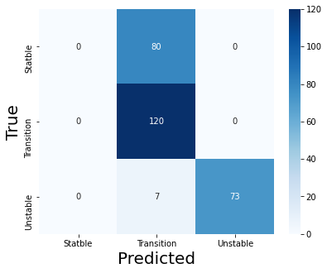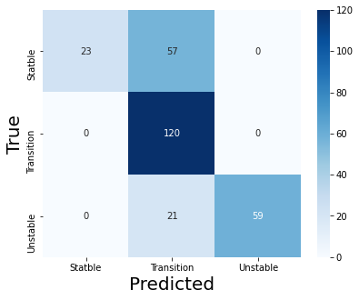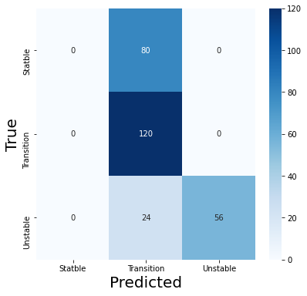

**(a) (b)**

**(c) (d)**

**Figure 4.7** Confusion matrices of test with time-frequency domain features(800 mm straight)

Table 4.7 represents the accuracy and F1 scores of the model tested with 800 mm length straight section combustor configuration data. The accuracies for Logistic Regression, Decision Tree, SVM, and Random Forest models were 0.82, 0.68, 0.72, and 0.62, respectively, while the F1 were 0.80, 0.58, 0.69, and 0.53, respectively, as shown in Table 4.7. The performance of the Decision Tree model was better than the Random Forest model due to the fewer data point available in this combustor configuration. The reason for the bad performance of ensemble methods(Random Forest) was random sampling of data in ensemble returns fewer sample points for the training of base learners.

Figure 4.7 shows the confusion matrices of models tested with 800 mm straight section configuration. (a) Indicates Logistic Regression, (b) Indicates Decision Tree, (c) Indicates SVM, and (d) Indicates Random Forest. There was total 80,120 and 80 true values for stable class, transition class, and unstable class, respectively. Out of these values, Logistic Regression recall was 100% in stable class, 100% in transition class, and 38.75% recall in unstable class. Decision Tree recall was 0% in stable class, 100% in transition class and 91% recall in unstable class. SVM recall was 28.75% in stable class, 100% in transition class, and 73.75% recall in unstable class. Random Forest recall was 0% in stable class, 100% in transition class and 70% in unstable class. Random Forest uses Decision Tree as a base learner hence, Random Forest performance was similar(0% recall of stable class) to the Decision Tree Model. The precision of a model is another parameter to check the model performance. it is defined as, the number of correct predictions out of the total number of predictions in for a class. The precision of Logistic Regression was 100% in stable class, 72% in transition class, and 100% in unstable class. The precision of the Decision Tree was 0%, in stable class 58% in transition class, and 100% in unstable class. The precision of SVM was 100%, 60%, 100% in stable transition and unstable class, respectively. Precision in Random Forest was 0%, 53.57%, and 100% in stable, transition, and unstable classes, respectively. The performance of the Decision Tree is very poor as compared to other models.

**Table 4.8** Testing accuracy and F1 score (800 mm end plate)

|  |  |  |
| --- | --- | --- |
| Algorithms | Testing Accuracy | F1 Score |
| Logistic regression | 0.86 | 0.84 |
| Decision Tree | 0.70 | 0.61 |
| SVM | 0.91 | 0.91 |
| Random Forest | 0.84 | 0.83 |

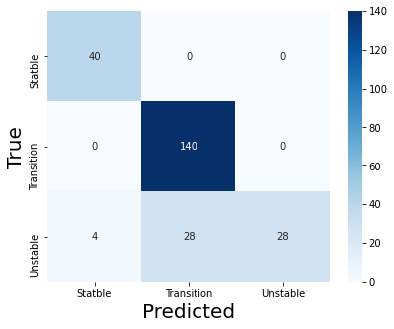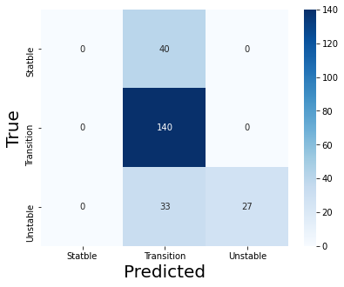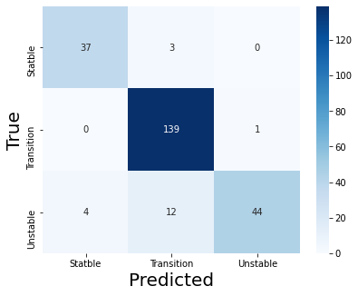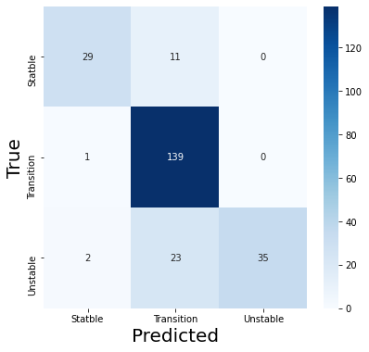

**(a) (b)**

**(c) (d)**

**Figure 4.8** Confusion matrices of test with time-frequency domain features(800 mm end plate)

Table 4.8 represents the accuracy and F1 scores of the model tested with 800 mm length straight section combustor configuration data. The accuracies for Logistic Regression, Decision Tree, SVM, and Random Forest models were 0.86, 0.70, 0.91, and 0.84, respectively, while the F1 were 0.84, 0.61, 0.91, and 0.83, respectively, as shown in Table 4.8. The performance of the Decision Tree was better than the Random Forest due to the fewer data point available in this configuration.

Figure 4.8 shows the confusion matrices of the model tested with 800 mm straight section configuration. (a) Indicates Logistic Regression, (b) Indicates Decision Tree, (c) Indicates SVM, and (d) Indicates Random Forest. There was total 80,120 and 80 true values for stable class, transition class, and unstable class, respectively. Out of these values, Logistic Regression recall was 100% in stable class, 100% in transition class, and 46.66% recall for unstable class. Decision Tree recall was 0% in stable class, 100% in transition class, and 45% recall in unstable class. SVM recall was 92.5% in stable class, 99.2% in transition class, and 73.33% recall in unstable class. Random Forest recall was 72.5% in stable class, 99.2% in transition class, and 58.3% in unstable class. As multiple models were trained using sampled data, the Random Forest model performance is better than Decision Tree Model. The precision of Logistic Regression was 90% in stable class, 83.33% in transition class, and 100% in unstable class. The precision of Decision Tree was 0%, in stable class 65.7% in transition class, and 100% in unstable class. The precision of SVM was 90% in stable class, 91% in transition class, and 99.2% in stable class. Precision in Random Forest was 90% in stable class, 80.3% in transition class, and 100% in unstable. The performance of the Decision Tree was poor as compared to other models (Decision Tree could not recall any data point in the stable class).

**Chapter 5**

**Conclusion And Future Scope**

**5.1 Conclusion**

Prediction of thermoacoustic instability in the premixed combustion chamber with four different combustor configurations (1000 mm combustor length straight section, 1000 mm combustor length with end plate at the end, 800 mm combustor length straight section, and 800 mm combustor length with end plate at the end ) was done using machine learning models. Data used for this study contains, thermoacoustic pressure amplitude with varying air flow rates. In the time domain, eight statistical features were extracted, and in the time-frequency domain, eight wavelet features were extracted. The data was divided into three different classes(stable, transition, and unstable) based on extracted features. Four machine learning models were trained using the feature matrix (Logistic Regression, Decision Tree, Support Vector Machine, and Random Forest). Trained models were tested with the remaining other types of combustor configuration data. Model’s performance with test data for straight section configuration was in the range of 80% - 97% and, for end plate configuration in the range of 65% - 91%. Random Forest models’ performance was 97% with time-domain features, it was better than other models’ performance in time-domain features. The SVM model performance using endplate configuration data was in the range of 86% to 91% for time-frequency domain features, which was better than the other three models. In the time-frequency domain, there was a significant difference between the F1 score and accuracy. This signifies that the overall model performance was more than individual class performance.

**5.2 Future Scope**

1. Only classical algorithms and one type of ensemble approach were utilised in this work; however, this can be expanded to other ensemble methods.
2. Time-domain statistical features can be extracted using hybrid methods (different combinations of formulas) which can distinguish the combustion status very well and increase the model performance.
3. If more data are available from the experiment, deep learning can be used to extract more relevant features. Also, deep neural networks can be trained to predict combustion status, provided sufficient data is available for training the neural networks.
4. Only one type of combustor configuration data was taken to train the models in this study, and the models were evaluated with remaining types of combustor configuration data. However, alternative combustor configuration data may be used to train models, and the remaining combustor configuration data can be used to test them.

**References**

1. . Kim, D. H., Kim, T. J., Wang, X., Kim, M., Quan, Y. J., Oh, J. W., ... & Ahn, S. H. (2018). Smart machining process using machine learning: A review and perspective on machining industry. International Journal of Precision Engineering and Manufacturing-Green Technology, 5(4), 555-568.
2. Awad, M., & Khanna, R. (2015). Machine learning in action: examples. In Efficient Learning Machines (pp. 209-240). Apress, Berkeley, CA.
3. Murugesan, M., & Sujith, R. I. (2015). Combustion noise is scale-free: transition from scale-free to order at the onset of thermoacoustic instability. *Journal of Fluid Mechanics*, *772*, 225.
4. Murugesan, M., & Sujith, R. I. (2016). Detecting the onset of an impending thermoacoustic instability using complex networks. *Journal of Propulsion and Power*, *32*(3), 707-712.
5. Murugesan, M., Singaravelu, B., Kushwaha, A. K., & Mariappan, S. (2018). Onset of flame-intrinsic thermoacoustic instabilities in partially premixed turbulent combustors. *International Journal of Spray and Combustion Dynamics*, *10*(3), 171-184.
6. Ahmed, H., & Nandi, A. K. (2019). Condition Monitoring with Vibration Signals (pp. 117-130). Wiley-IEEE Press.
7. Alsberg, B. K., Woodward, A. M., & Kell, D. B. (1997). An introduction to wavelet transforms for chemometricians: A time-frequency approach. Chemometrics and intelligent laboratory systems, 37(2), 215-239.
8. Andrew Ng “Coursera: Machine Learning” https://www.coursera.org/learn/machine-learning (accessed Jun. 15, 2021).
9. Kubat, M. (2017). An introduction to machine learning. Springer International Publishing AG.
10. Jurkovic, Z., Cukor, G., Brezocnik, M., & Brajkovic, T. (2018). A comparison of machine learning methods for cutting parameters prediction in high speed turning process. Journal of Intelligent Manufacturing, 29(8), 1683-1693.
11. Du Preez, A., & Oosthuizen, G. A. (2019). Machine learning in cutting processes as enabler for smart sustainable manufacturing. Procedia Manufacturing, 33, 810-817.
12. Wuest, T., Weimer, D., Irgens, C., & Thoben, K. D. (2016). Machine learning in manufacturing: advantages, challenges, and applications. Production & Manufacturing Research, 4(1), 23-45.
13. Al Assadi, H. M. A. A., Wong, S. V., Hamouda, A. M. S., & Ahmad, M. M. (2004). Development of machine learning strategy for acquiring on-line machining skills during turning process. *Journal of materials processing technology*, *155*, 2087-2092.
14. Hoeijmakers, M., Kornilov, V., Arteaga, I. L., de Goey, P., & Nijmeijer, H. (2014). Intrinsic instability of flame–acoustic coupling. *Combustion and Flame*, *161*(11), 2860-2867.
15. Jafarian, F., Taghipour, M., & Amirabadi, H. (2013). Application of artificial neural network and optimization algorithms for optimizing surface roughness, tool life and cutting forces in turning operation. *Journal of Mechanical Science and Technology*, *27*(5), 1469-1477.